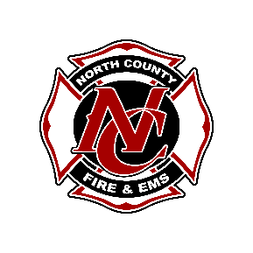
North County Regional Fire Authority
Job Shadow/Rider Expectations

In order to ride with our crews, the following is required:
- The release form will be signed (by a parent or guardian if you are under 18) and turned in to the Captain upon arrival at the station.
- Long dark pants or jeans (no holes) are required.
- We (NCRFA) will provide a t-shirt for you to wear while you are riding. It must be worn the entire time you are with us and returned when the allotted time for your ride-a- long/job shadow is done.
- You must arrive on time.
- Please stand to the side and observe what the crews are doing.
- Be polite and respectful.
- Ask questions when appropriate.
- Listen to what the crews say and follow their directions.

If these expectations are not met, you will not be able to participate.
We look forward to sharing our experiences with you in a safe and educational environment.

